Configure Oracle 19c ASM and ACFS Filesystem Procedure

Marsh DBA Group

1. Prerequisite

Can run ASMCA to configure these ASM Disk groups.

Have proper ASM disk groups in place and enough available space before creating a new database. For example,

GEN_PROD_DATA01

GEN_PROD_FRA01

GEN_PROD_TEMP01

1. Configure ASM

Start an X server process on the local machine. (xming is a good free product for this)

Log onto server using an individual id and copy the .Xauthority file to /tmp/<userid>.Xauthority (i.e. /tmp/npranger.Xauthority)

cp .Xauthority /tmp/<userid>.Xauthority

Change permissions on /tmp/<userid>.Xauthority to be 777

chmod 777 /tmp/<userid>.Xauthority

Sudo to become the oragrid user using the following command:

sudo –u oragrid –i

Copy the .Xauthority file from the tmp location to the oragrid user’s home directory :

cp /tmp/<userid>.Xauthority .Xauthority

Set up the environment for various Oracle related variables:

Type the command : asm (this executes an environment file via an alias set up in the .profile)

Run the asmca tool using the following command:

oragrid@usdfw23db18vcn1:NOSID>cd /opt/oragrid/product/19/grid/bin

**./asmca**

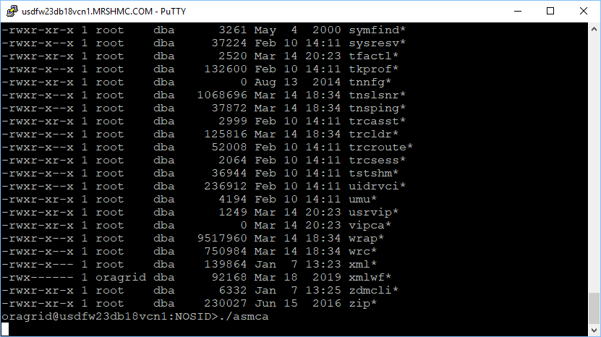

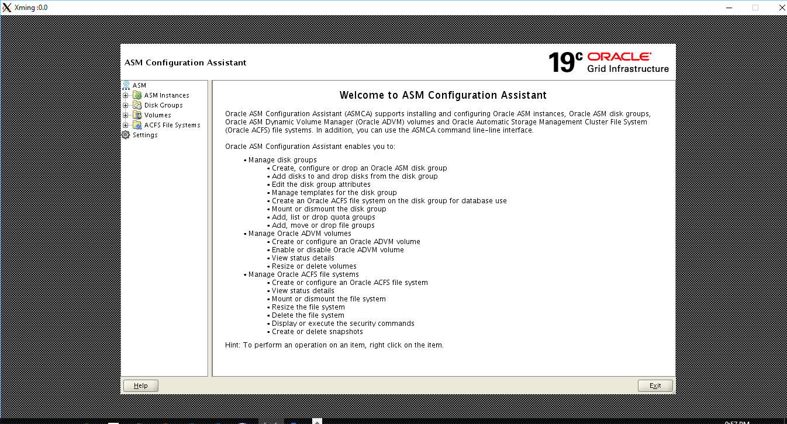

Once the ASM Configuration Assistant has started the below screen will be presented that shows all of the currently configured ASM disk groups and their sizes.

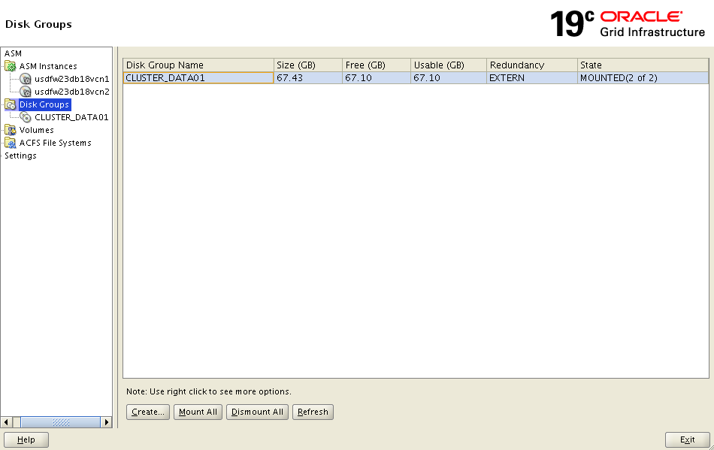

Right click “Disk Groups” and then click “Create”

The first task to perform will be to create any additional ASM Disk Groups needed by the databases that will be run on the server. To do this click on the “Create” button on the Disk Groups tab to bring up the Create Disk Group screen seen below. On the Create Disk Group screen a Disk Group Name will need to be provided that is named according to the Marsh ASM standards document that can be found on the DBA sharepoint portal. To set up these disk groups the “External (None)” redundancy radio button should be selected and all disks that will participate in the disk group should have their check box checked. Once this is completed click on the “OK” button to create the Disk Group.

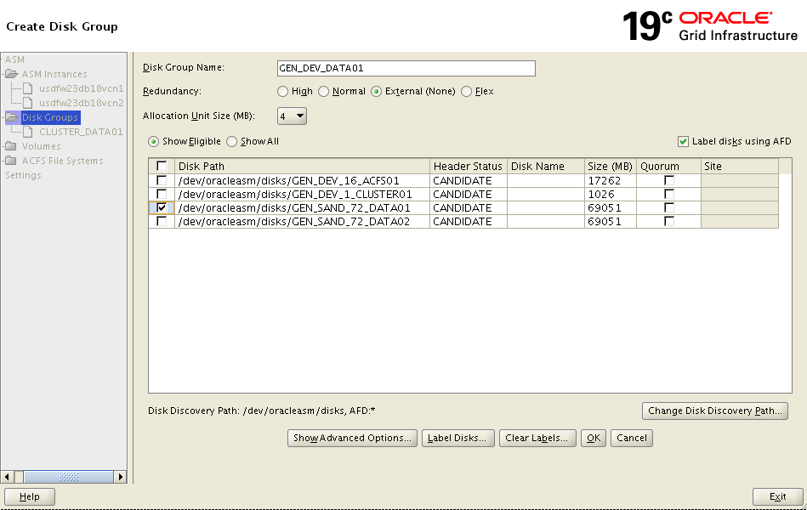

Click “OK”

Click “Create” again to create FRA related ASM disk group.

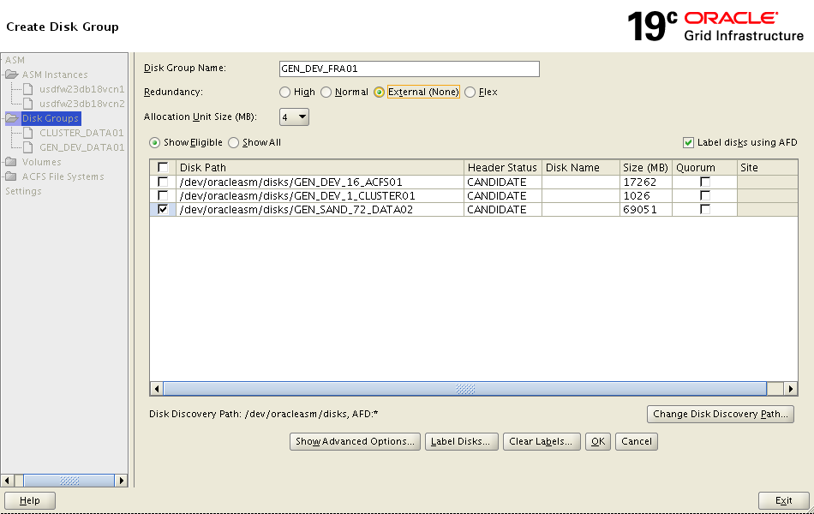

Click “OK”

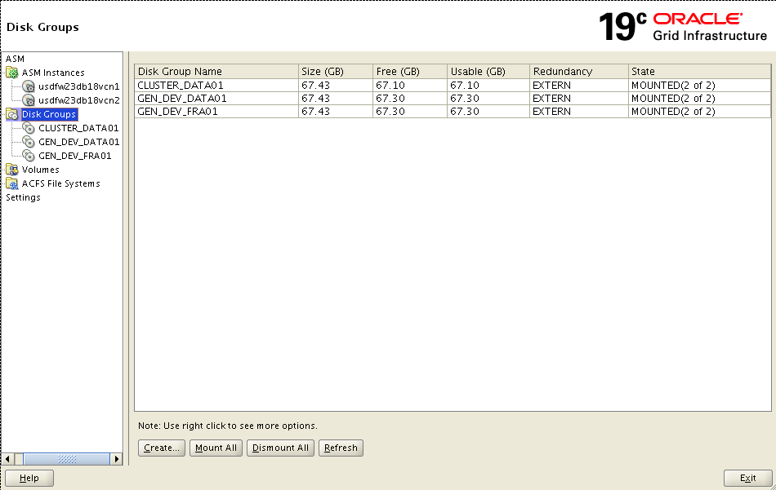

Click “Create” to create TEMP related ASM disk group.

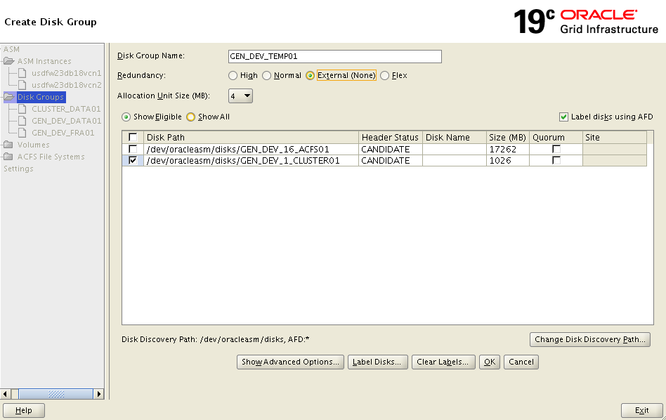

Click “OK”.

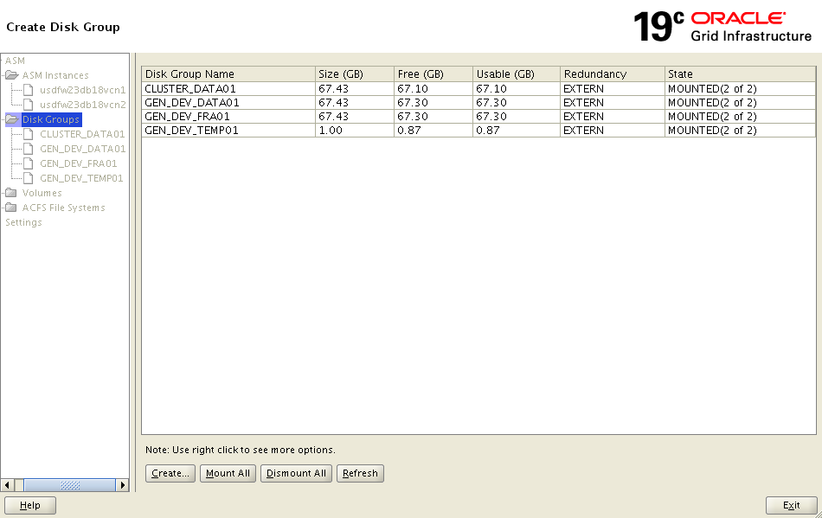

In order to create the ACFS file system to be used for the /var/oracle/admin shared mount points an ASM Disk group will need to be created to base the disk volume on. Go to the Disk Group screen and click on the “Create” button.

Create ASMCFS DISK Group to be used by /var/oracle/admin

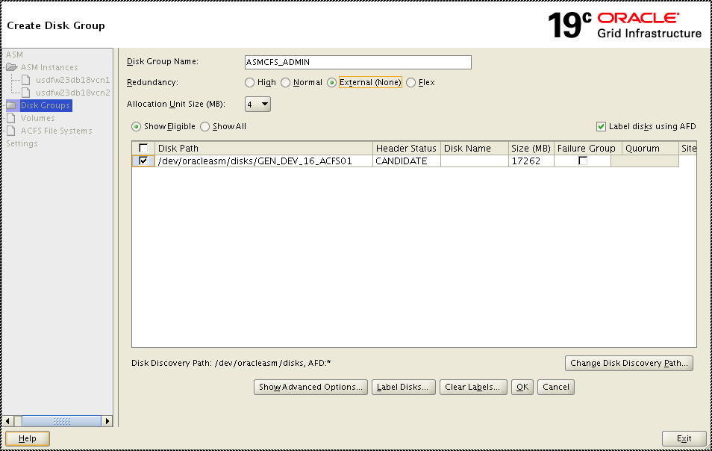

Click Create” and “OK”

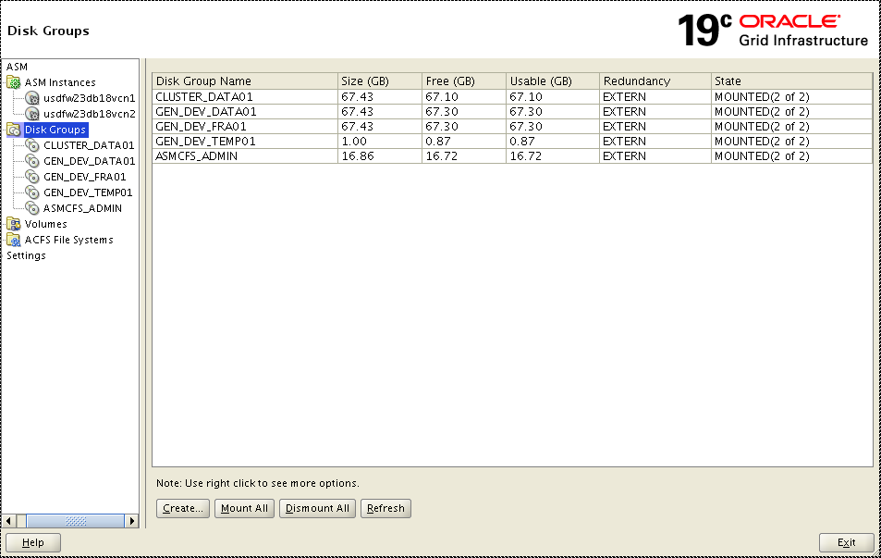

Click “Volumes”

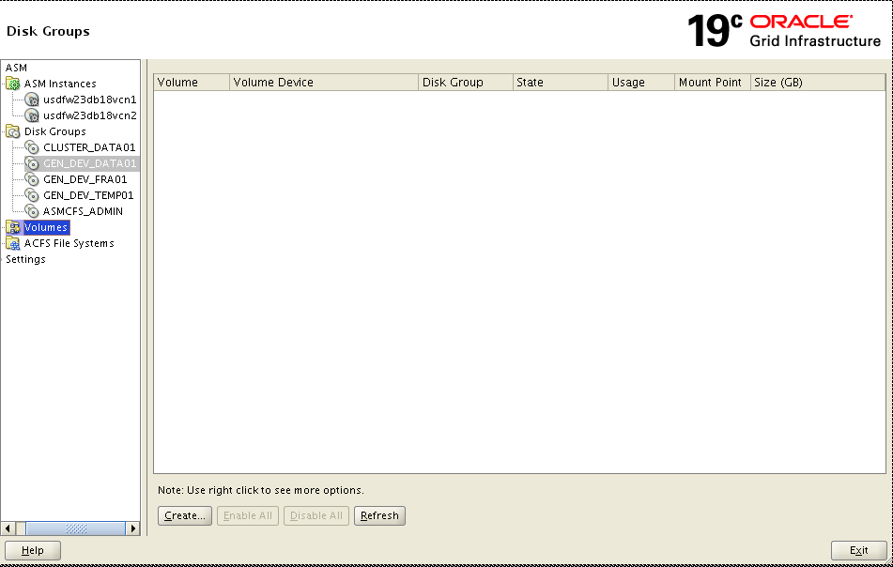

Click “Create”

On the Create Disk Group screen a Disk Group Name will need to be provided that reflects the use of the disk group. For the database admin disk group the name ASMCFS_ADMIN will be used on all clusters. This disk group redundancy radio button for “External (None)” should be selected since it is based on SAN drives and finally all disks that will participate in the disk group should be selected. Once this is completed click on the “OK” button to create the disk group.

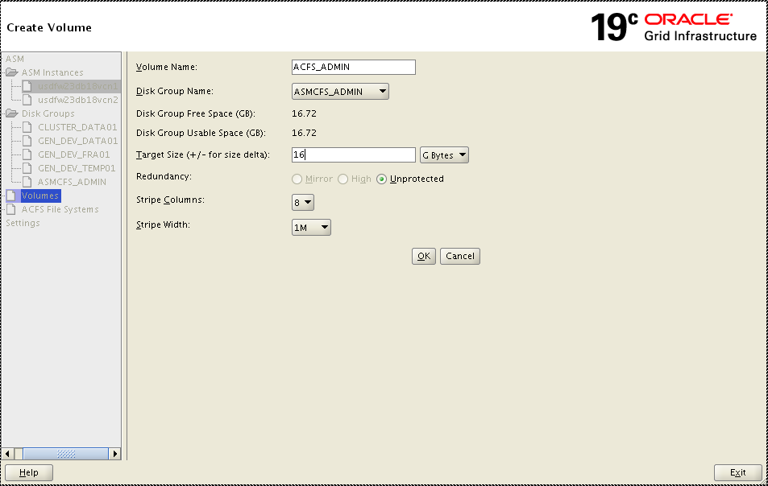

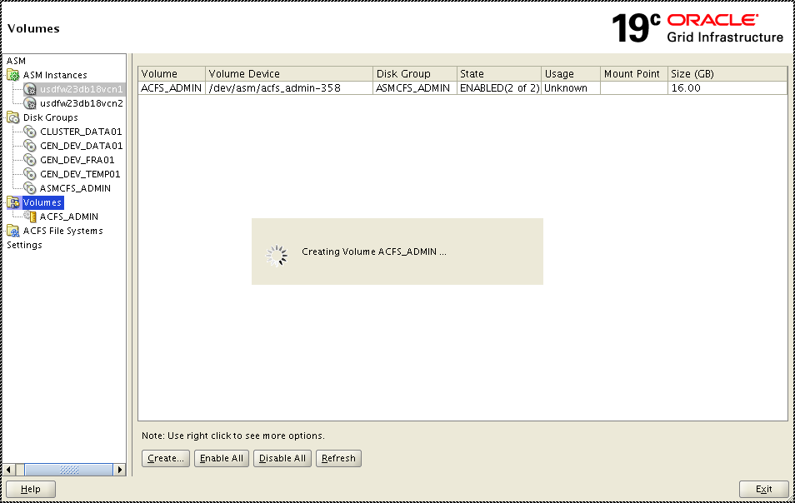

On the Create Disk Group screen a Disk Group Name will need to be provided that reflects the use of the disk group. For the database admin disk group the name ASMCFS_ADMIN will be used on all clusters. This disk group redundancy radio button for “External (None)” should be selected since it is based on SAN drives and finally all disks that will participate in the disk group should be selected. Once this is completed click on the “OK” button to create the disk group.

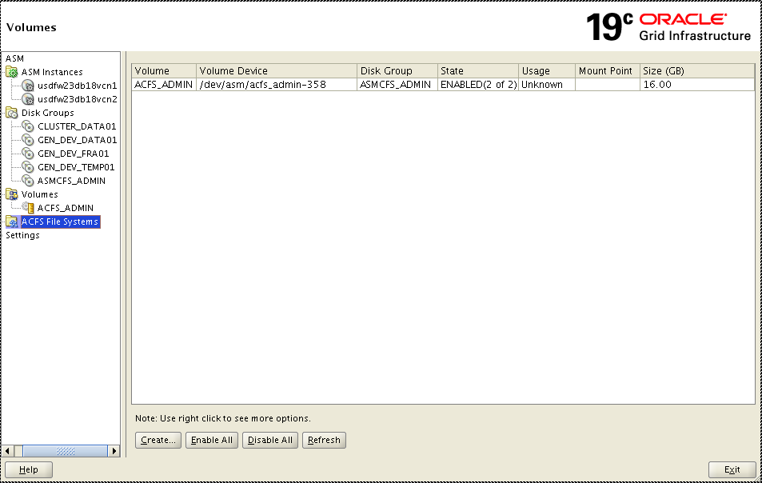

Click “ACFS File Systems”

To “Create” to create /var/oracle/admin filesystem using AFCS filesystem

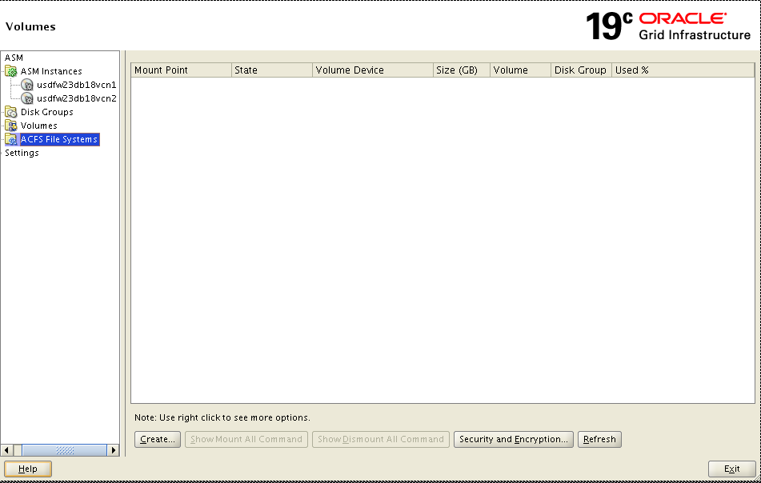

Click “Create”

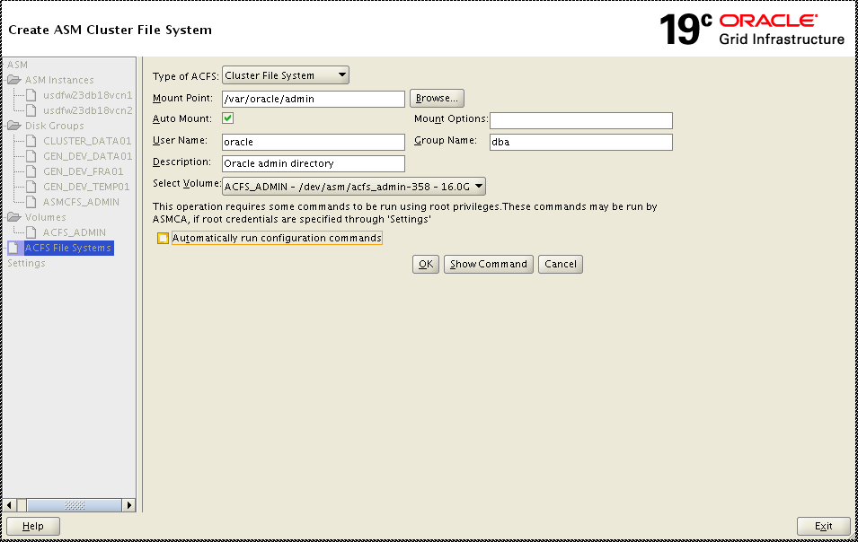

Click “Show Command”

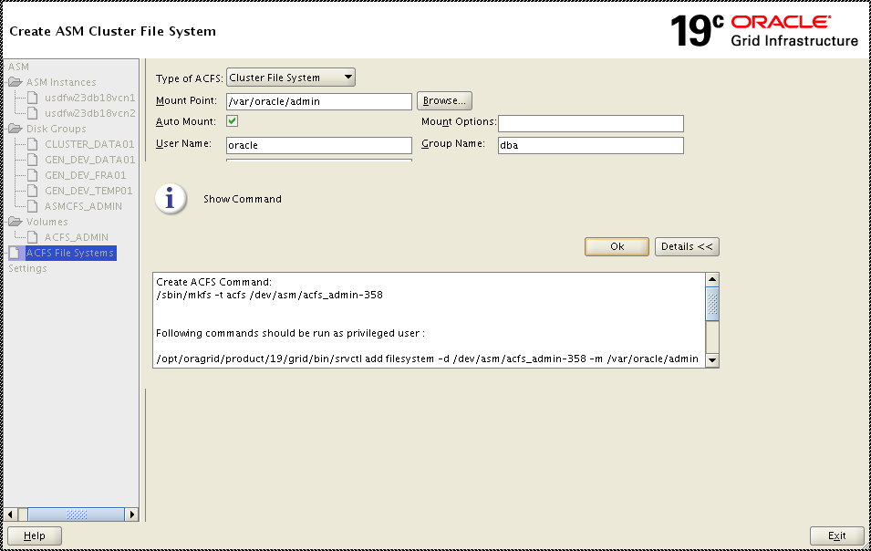

Click “OK”

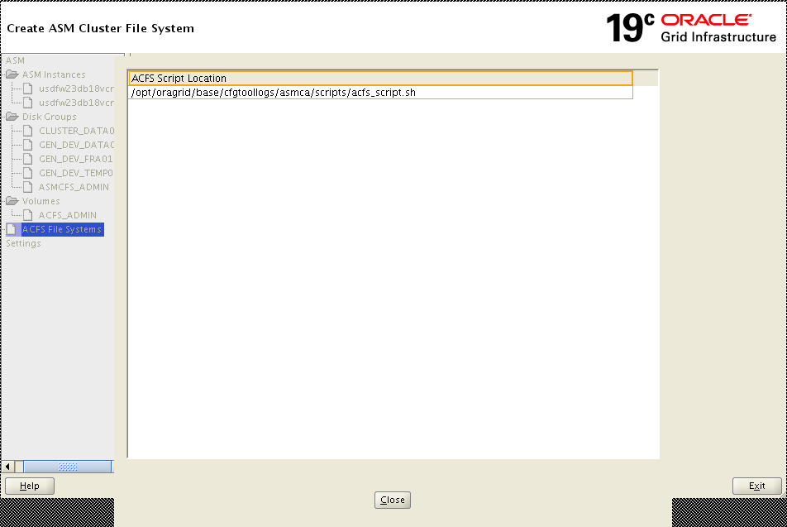

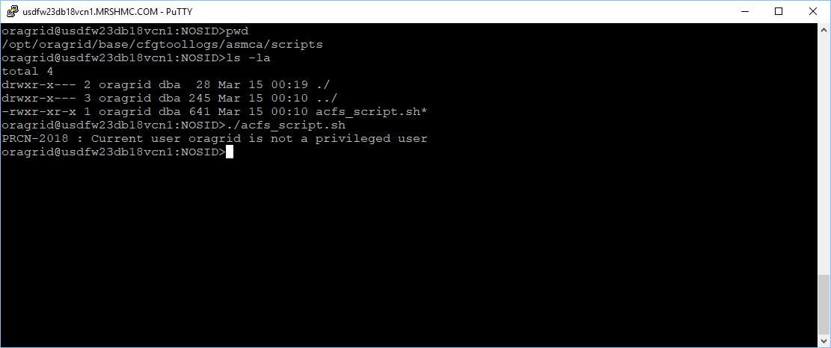

root@usdfw23db18vcn1:NOSID>./acfs_script.sh

ACFS file system /var/oracle/admin is mounted on nodes usdfw23db18vcn1,usdfw23db18vcn2

root@usdfw23db18vcn1:NOSID>

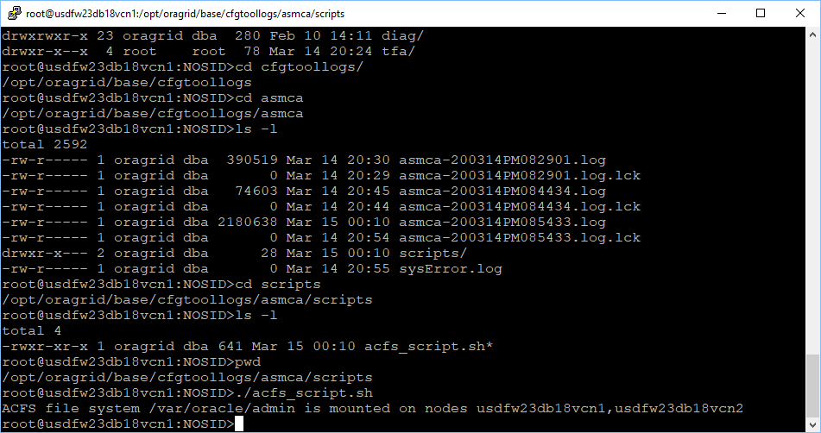

Click “Close”

